Steps to Configure Jenkins Job for Automated Database Backup

Step 1: Log in to Jenkins
Access the Jenkins web interface using the provided URL.
Log in with the administrator credentials to gain access to job configuration features.
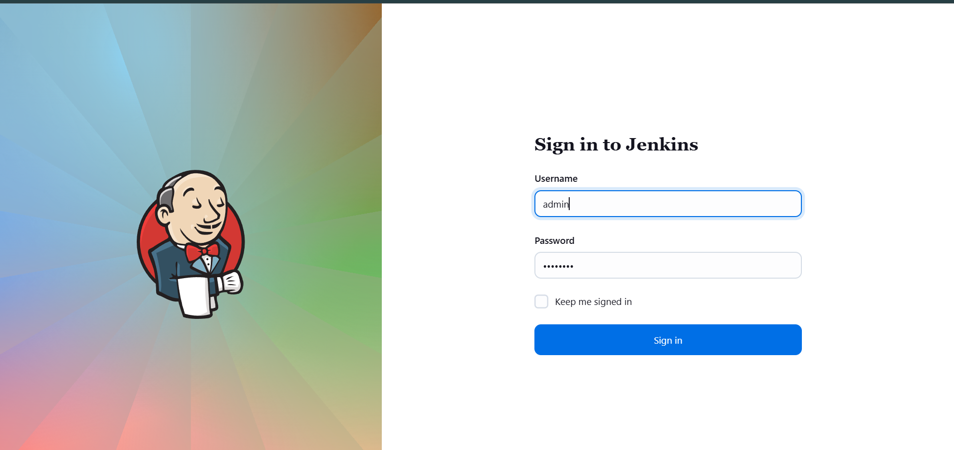

Step 2: Create a New Jenkins Job
From the Jenkins dashboard:
- Click New Item.
- Enter the job name as database-backup.
- Select Freestyle project as the job type.
- Click OK to proceed to job configuration.
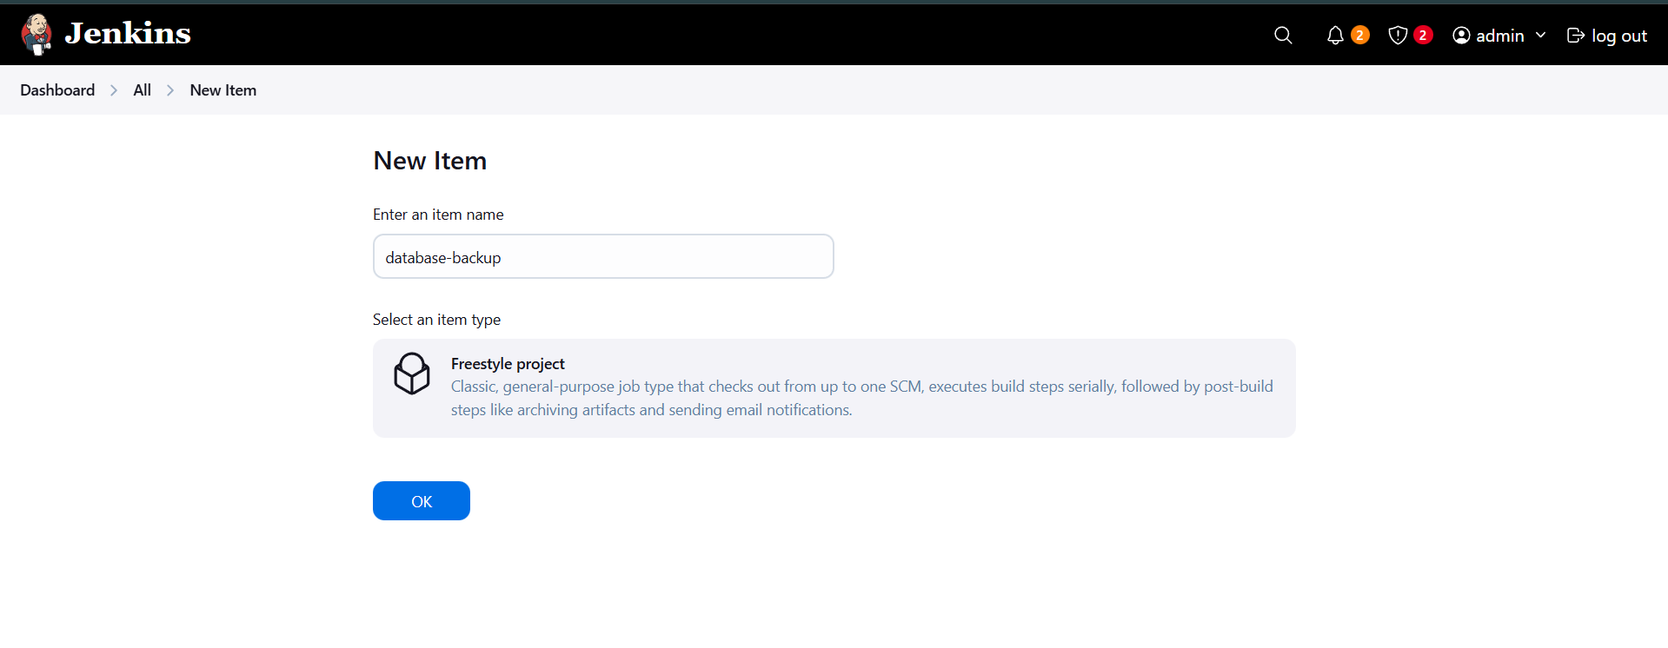

Step 3: Configure Job Scheduling
- Navigate to the Triggers section.
- Enable Build periodically.
- In the Schedule field, enter the cron expression:
- */10 * * * *
This configuration ensures the job runs automatically every 10 minutes.
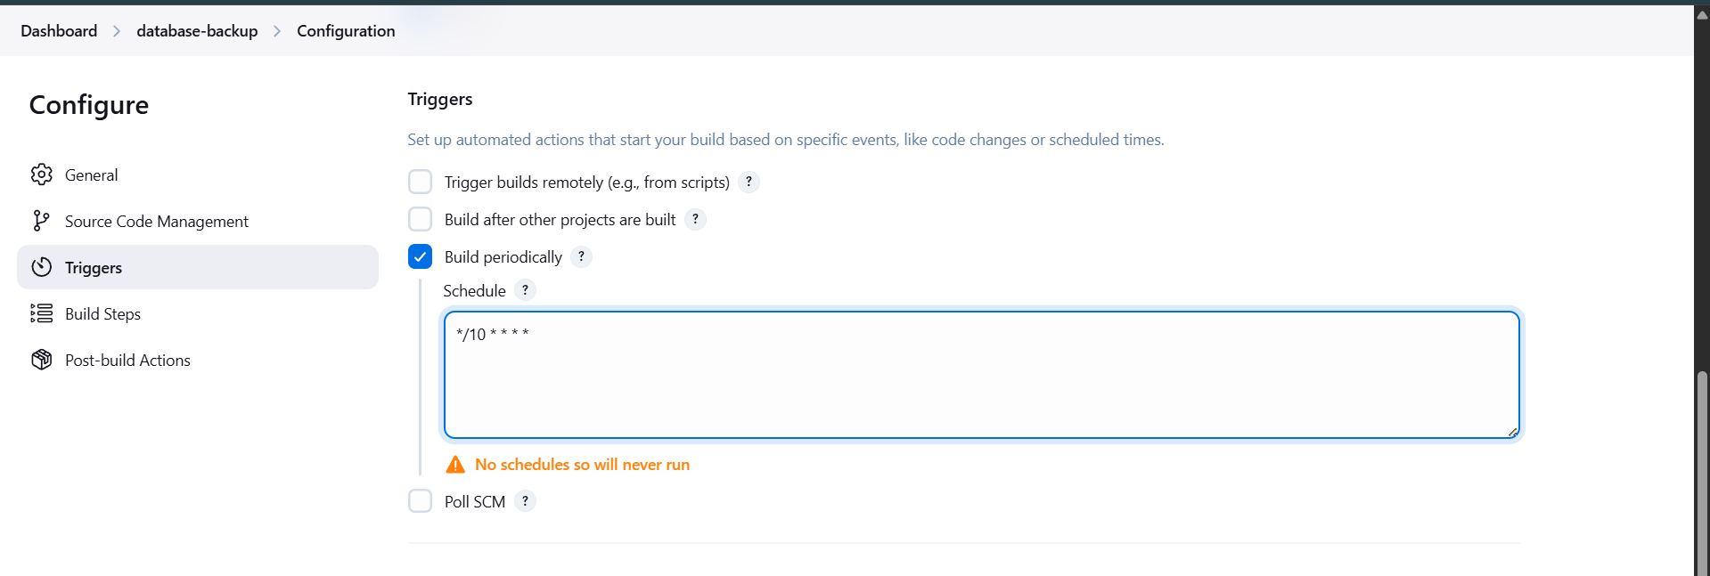

Step 4: Set Up Passwordless SSH from Jenkins Server
Log in to the Jenkins server and switch to the Jenkins user if required.

4.1 Generate SSH Key Pair
Generate an SSH key pair to allow Jenkins to connect to remote servers without manual password entry:
ssh-keygen -t rsa
Accept the default file location and do not set a passphrase.
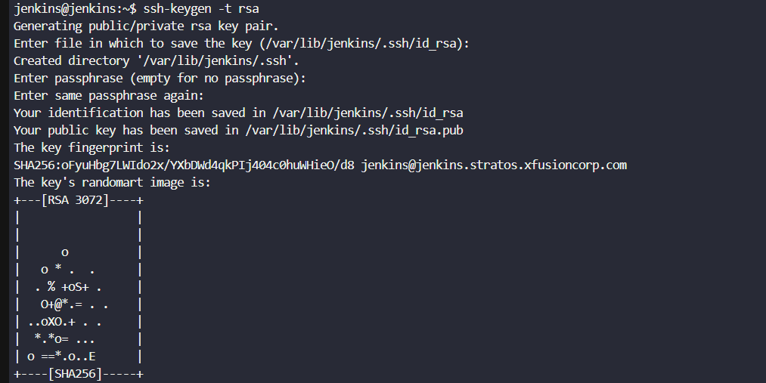

Step 5: Copy SSH Key to Database Server
Copy the Jenkins public key to the database server to enable secure access:
ssh-copy-id peter@stdb01
Enter the database server user password when prompted.
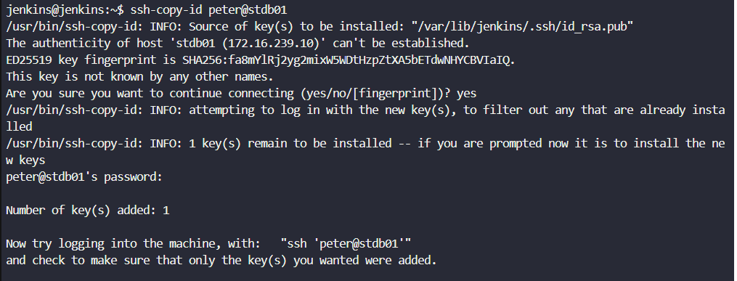

Step 6: Copy SSH Key to Backup Server
Repeat the same process for the backup server:
ssh-copy-id clint@stbkp01
This allows Jenkins to transfer backup files to the backup server without authentication issues.
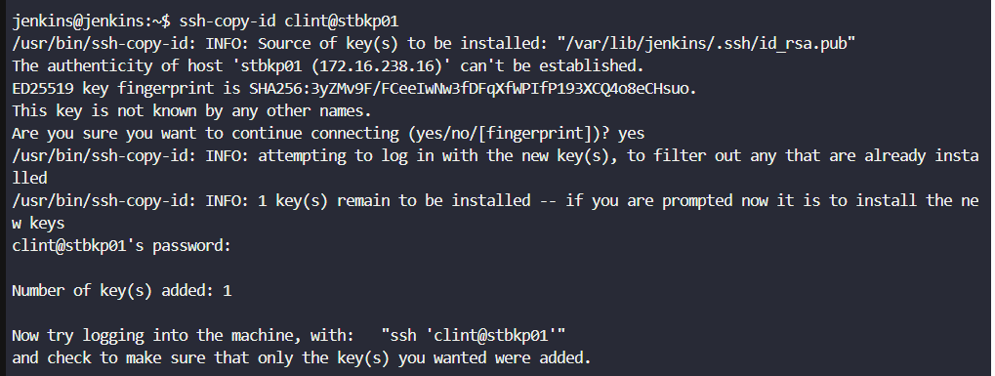

Step 7: Configure Build Step (Execute Shell)
- Go to the Build Steps section.
- Click Add build step → Execute shell.
- Add the following command:
ssh peter@stdb01 "mysqldump -u kodekloud_roy -pasdfgdsd kodekloud_db01" > db_$(date +%F).sql && scp db_$(date +%F).sql clint@stbkp01:/home/clint/db_backups

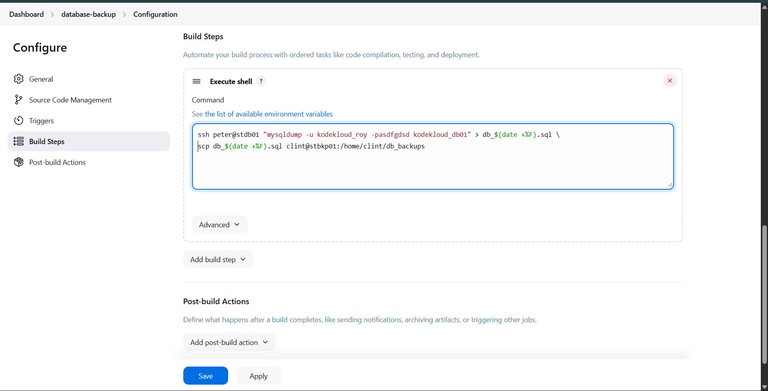
Explanation:
- Connects to the database server via SSH.
- Takes a MySQL dump of the specified database.
- Saves the dump with the current date in the filename.
- Copies the backup file to the backup server directory.

Step 8: Save and Run the Job
- Click Save to apply the configuration.
- Manually trigger the job once using Build Now to validate execution.

Step 9: Verify Job Execution in Jenkins
Open the Console Output of the build and confirm:
- Database dump command executed successfully.
- File transfer to the backup server completed.
- Build status shows SUCCESS.
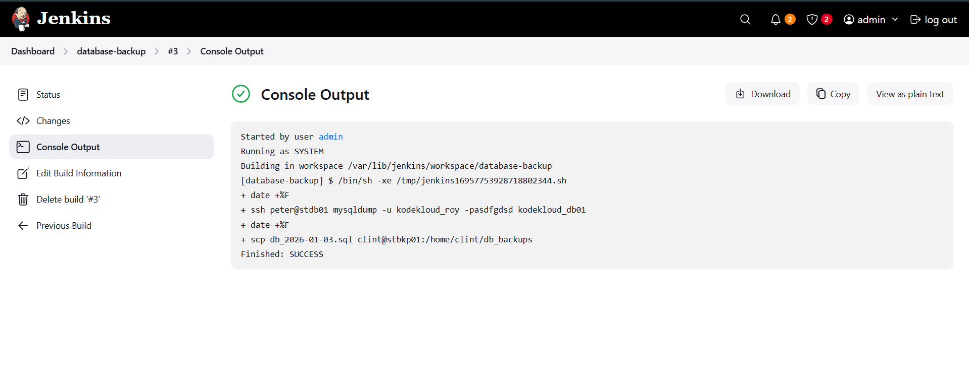

Step 10: Verify Backup on Backup Server
Log in to the backup server and check the backup directory:
ls -l /home/clint/db_backups
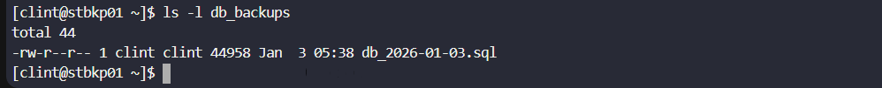
Confirm that the database dump file with the current date is present.

